20CYS281 OS LAB 1 ASSIGNMENT

Commands Used:

1. mkdir 20CYS281

2. touch U4CYS23036.txt

3. vim U4CYS23036.txt

4.cd 20CYS281 | mkdir Lab

5. mv U4CYS23012.txt 20CYS281/Lab/Copied_file.txt

6. cd U4CYS23036/Lab

7. chmod -w Copied_file.txt

8. ps aux

9. cat Copied_file.txt

10. ifconfig

Qn1,

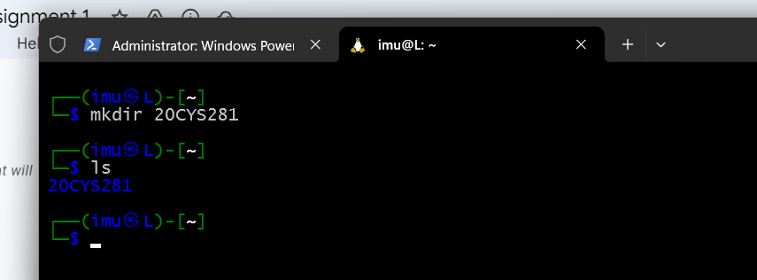

Qn2,

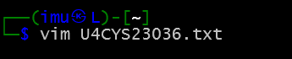

Qn3,

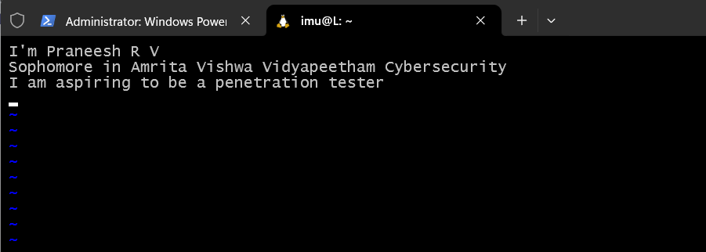

Qn4,

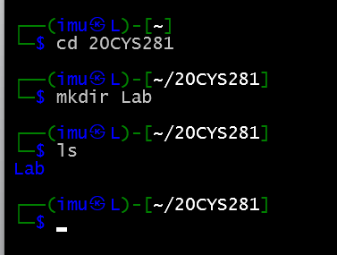

Qn5,

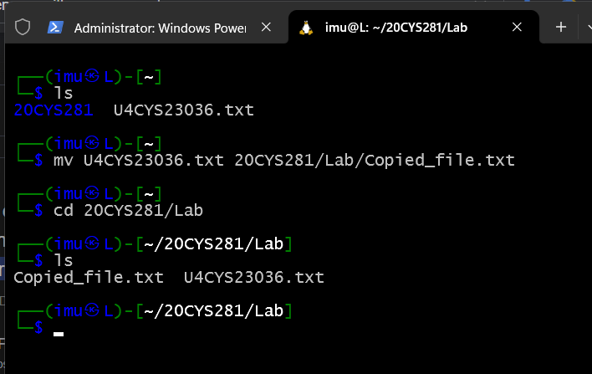

Qn6,

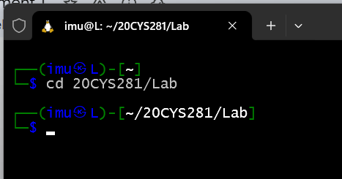

Qn7,

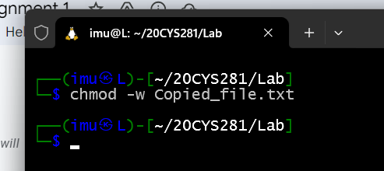

Qn8,

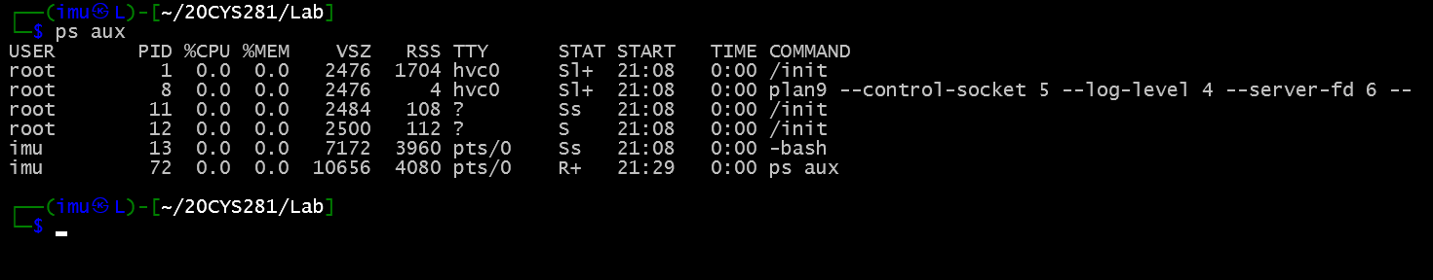

Qn9,

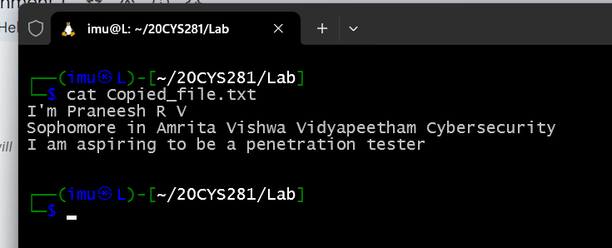

Qn10,

